SEAR-AR-05-DataAnalysis

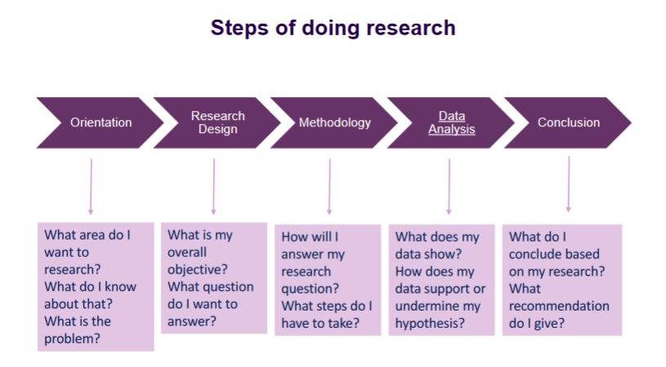Full Steps of doing research:

Identifying our data

Variable:

* Is attribute of object
* E.g., object is person in survey, attribute is age, family status, salary, browser name, monitor resolution, …
* Variables defined when defining survey

Value:

* Is value of variable
* (numerical) amount or some measure derived from the category
  + Temperature value: 5°C, 25°F
  + Salary value: $1500, 500€-1000€
  + Browser value: Firefox, Safari, Chrome

Variable types:

* Variables come in types
  + Temperature in degrees
  + Salaries often in ranges
  + Browser: name is variable, but value is string and cannot be calculated with
* Four types of types: nominal, ordinal, interval and ratio

Types:

* Nominal:
  + Discrete values (categorical)
  + No ordering
  + Difference between values has no meaning
  + E.g., Which browser people use: Firefox, Opera, Chrome
* Interval:
  + Continuous values
  + Ordering
  + Meaningful difference between two values
  + E.g., Temperature in °C or °F: 35°C > 34,9°C > … > 3°C > … > -15°C > …
* Ordinal:
  + Discrete values
  + Ordering
  + Meaningful difference between two values
  + E.g., Education of level: No qualification, High School, Bachelor, Master
* Ratio:
  + Continuous
  + Ordering
  + Meaningful difference between two values
  + Defined zero-point: a value of 0 means none of the variable
  + E.g., Temperature in Kelvin: 373.15K > … > 273.16k > … > 0K

“Road” of defining variables and values

